**Learning Activity-02:**

The following is a design layout using CSS box model. Use appropriate HTML elements and CSS properties (use external CSS files) to create the above layout.

**Full screen view:**

**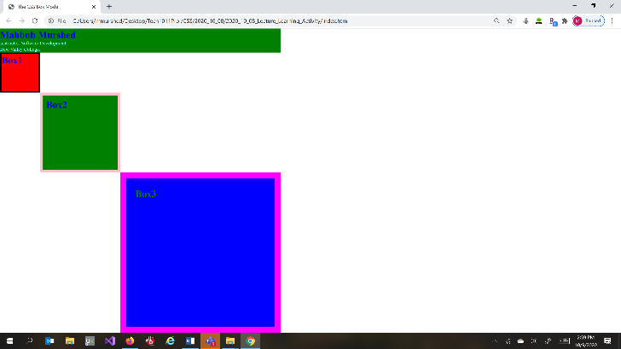  
  
What happens when screen size changes:**

|  |  |  |
| --- | --- | --- |
| **When the screen width and height changes proportionally.** | **When only the screen height changes.** | **When only the screen width changes.** |
|  |  |  |

**Rubrics and Evaluation**

This activity will be graded for both design and functionality.

|  |  |
| --- | --- |
| **Design Task** | **Marks** |
| * **Is the page layout similar to the given layout?** * **All of the boxes are squares. The boundary width of Box2 should be twice as the boundary width of Box1. Again the boundary width of Box3 should be four times the boundary width of Box1.** * **Does the boxes touches corner to corner?** * **Does the boxes takes the entire screen width?** * **Does the boxes color matches with the provided design?** * **Does the texts have the padding/margin as per design diagram?** * **Does the boxes have variable length border width?** | 5 |
| **Code quality**   * **Is the code clear and easy to read?** * **Is the style (square boxes) consistent across different window sizes?** * **Is their appropriate comments** (<!-->) **and appropriate spacing?** * **Does the square boxes change their width but still maintain the width-ratio when the window size is changed?** * **Does the page work with all common web browsers?** | 5 |
| **Total** | 10 |